Proof of Part 4 & 5 Review/Questions
Due Monday, November 19, 2018
Instructions:
- Open this document and read all project instructions.
- As you read, feel free to highlight, star, or otherwise note information that you find interesting or confusing.
- Click on “Review” on the menu on the top of this page. Then click “New Comment.” Write any questions or comments you have in the comment bubble.
- You will see something like this:
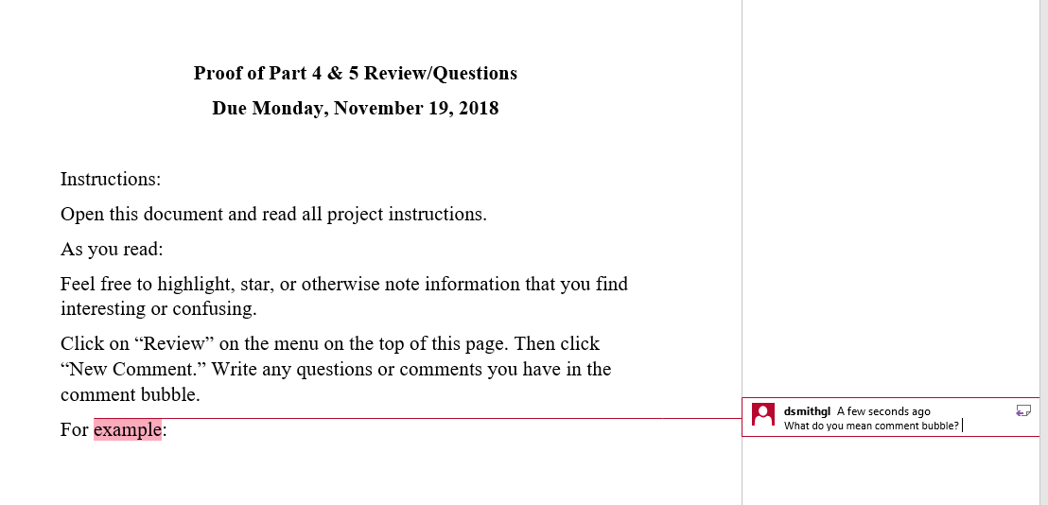
- Leave me at least 5 comments spread evenly throughout the document. In other words, do not just comment on the first 2 pages. There must be clear evidence that you read the entire document.
- This is your chance to get clarification from me. I will read and respond to all your comments prior to your submission of part 4.
- Students will not be allowed to work on their Photoshop Illustrations until they have completed the review.
- Students who arrive to Rowley G217 on Monday, November 26, without having completed this, will use valuable lab time completing this assignment prior to working on Photoshop Illustrations.
- Completion of this review is mandatory. Students who complete this by 11/19 will receive 5 bonus points. Students who complete this after 11/19 will be required to complete it before working on Photoshop Illustrations in the lab and will not receive any bonus points.
- Submit to Canvas Under Assignments-Store Design Inquiry Learning Project-Proof of Part 4 & 5 Review

Continue to Next Page

Store Design Inquiry Learning Project: Part 4:
Floor Plan and Store Concept Analysis Report & Photoshop Illustrations

Note: Use the checkboxes below to check off each step as you read each point and complete the
assignment.

For this assignment, you will draw from your sources on trends in visual merchandising (scholarly articles and trade publications Visual Merchandising and Store Design, WGSN, Women’s Wear Daily (WWD), WindowsWear PRO, as well as the Internet), sources used for brand and location analysis, and your store observations to make recommendations for improvement of your chosen retailer’s store concept.

Step 1:
- Refer to Store Design Inquiry Learning Project: Part 3: Independent Field Trip & Written Store Observations: Step 7. List your proposed recommendations and solutions related to the problem areas. Indicate how you would make improvements to deal with the problems you found. (Remember the problem states that you are to make changes that would “improve its profit and sales volume”.) Indicate how trends in visual merchandising influenced the changes you have made.
  - Your recommendations/solutions must be backed by research! This means that your proposed recommendations and solutions must relate to trends discussed in the articles you found.
  - The recommendations and solutions must also reflect the store’s format (store type: specialty store, department store, etc.), brand image, and be appropriate for the target market. Therefore, these recommendations and solutions must be backed by your research on the store’s brand image and target market.
  - Include citations to relevant sources next to your recommendations and sources in an effort to provide “evidence” that your reasoning behind solutions and recommendations are academically sound.

Step 2:
- Create a PowerPoint Slide with the Heading “Proposed Store Layout”
- Refer to the Photoshop Lecture on Floor Layout and create a new store layout (an overhead view of only the sales floor indicating a traffic pattern through the arrangement of fixtures, displays, etc.)
- The new store layout should address any issues you identified during your store observation and should successfully lead the customer throughout the entire store
- Refer to the PPT formatting lecture “PresentationTips” and the PPT template – demo to size the slide appropriately
- Insert a JPEG (image) of the store layout you created in Photoshop (sized no larger than 10 x 10 inches)
- Include a few brief, bulleted statements explaining how you made the new store layout more effective and resolves any issues of the actual store layout you observed
- When designing your slides:
  - Refer to Lecture: PPT Best Practices and follow the guidelines discussed
  - Ensure that your PowerPoint slides should also demonstrate mastery of the elements of design discussed in lecture
Step 3:
- Create as many PowerPoint Slides as needed with appropriate headings to address all other inquiry questions
- List proposed recommendations and solutions to the problem areas you identified (on separate slides, if necessary) (style of mannequins, use of fixtures, interior décor, etc.) using short, bulleted phrases and include citations to relevant sources
- Include a few brief, bulleted statements explaining how these recommendations/solutions will resolve the issues you observed at the store
- Refer to the PPT formatting lecture “PresentationTips” and the PPT template – demo to size the slide appropriately
- On one of the slides, insert a JPEG (image) of the Store Concept Storyboard you created in Photoshop (sized no larger than 10 x 10 inches)
  - Refer to Photoshop Lecture 1
  - The storyboard should include relevant illustrations, photographs, story boards, or images that visualize the recommendations/solutions you are proposing
- On another slide, insert a JPEG (image) of the Planogram you created in Photoshop (sized no larger than 10 x 10 inches)
  - The planogram should propose new, more effective merchandise guidelines and directives and visually provide recommendations and solutions for issues regarding the organization of merchandise on the sales floor (merchandise placement guidelines) and fixture presentation guidelines.
  - You may use the planogram to propose merchandising product according to a dominant aspect (i.e. color, size, price, brand name/designer, coordination/style, end use)
  - Include a few brief, bulleted statements explaining how the new planogram will assist in resolving any issues you observed at the store
- When designing your slides:
  - Refer to Lecture: PPT Best Practices and follow the guidelines discussed
  - Ensure that your PowerPoint slides should also demonstrate mastery of the elements of design discussed in lecture

Step 4:
- Use the following rubric as a checklist to ensure that you have completed the assignment correctly:

Store Design Inquiry Learning Project: Part 4:
Floor Plan and Store Concept Analysis Report & Photoshop Illustrations
Adherence to assignment instructions | /10
Quality of PowerPoint  (PPT are formatted according to PPT: Best Practices Lecture, demonstrates mastery of the elements of design, is properly size to accommodate 10 x 10 Photoshop images) | /10
Store layout  Effective and appropriate to store type, brand image, and target market | /40
Store Concept  Demonstrates mastery of the elements of design and technical skill, representative  recommendations/solutions proposed, appropriate to brand image and target market | /40
Planogram  Demonstrates mastery of the elements of design and technical skill, representative  recommendations/solutions proposed, dominant aspect is appropriate to store type, demonstrates understanding of fixture presentation guidelines | /40
Defined/Sound Methodology  Inquiry project/paper has defined focus, methodology or framework—active  research & sound reasoning | /15
Information Literacy  Project/paper indicates documentation of information—citations, evaluation and  inclusion of Sources—information literacy | /15
Critical Thinking  Considers differing perspectives, assesses data or evidence, reaches appropriate  conclusions—critical thinking | /15
Analysis & Deliberation  Project/paper works as an academic paper in scope, focus, analysis, deliberation  and execution. | /15
Total Possible Points | /200

Step 5 : Canvas Submission:
▪ Go to Canvas and locate the assignment group titled “Store Design Inquiry Learning Project”
- Within that group, click on the assignment titled “Part 4: Floor Plan and Store Concept Analysis Report & Photoshop Illustrations”
- Upload single PowerPoint file containing all slides by Monday, December 3, 2019, at 1:45 PM

Store Design Inquiry Learning Project: Part 4:
Photoshop Illustration Assignment Instructions

What are we doing? : Based on our research and store observations, we are designing a new or improved proposed store concept, store layout, and a planogram for the stores we are researching for the Store Design Inquiry Learning Project.

A store concept is a collection of ideas regarding the store or company’s vision, mission, product offering, supply chain, visual merchandising, and more. The store concept you design will include only elements of visual merchandising and a representation of the store’s products. All required elements is included in the store concept Photoshop illustration assignment requirements below. Refer to Canvas> 4. Photoshop Lectures> Photoshop Lecture 1: Store Concept>1. Photoshop Lecture 1. Docx for step-by-step instructions to create a store concept image.

A store layout is different from a floor plan. A floor plan indicates all non-selling and selling space, whereas a store layout is a plan of the sales floor (selling space only) that indicates traffic patterns or the retailer’s desired route designed to move shoppers past fixtures of merchandise. Store layout Photoshop illustration assignment requirements are included below. Refer to Canvas> 4. Photoshop Lectures> Photoshop Lecture 2: Floor Plan_Store Layout> Floor Plan – Store Layout - Photoshop Lecture.docx for step-by-step instructions to create a store layout.

A planogram contains detailed diagrams, drawings, or photographs of the displays so that the visual team in each store location can interpret how to implement the setup. Planograms include merchandising standards, which convey the “formula or hierarchy” for the location and display of merchandise. There are 2 parts to a planogram: 1) An image that displays merchandise as it appears on the wall. We will do this part in Photoshop, and 2) “Grid” that identifies where the exact merchandise will be placed by listing the product information beneath the image (product name, style number, & price). We will do this part in Microsoft Word. Planogram Photoshop illustration assignment requirements are included below. Refer to Canvas> 4. Photoshop Lectures> Photoshop Lecture 3: Planogram> Planogram Photoshop Lecture.docx for step-by-step instructions to create a planogram.

Why are we doing this? : We are doing this for 4 reasons: 1) To become proficient in proficient in visual communication, an important fashion industry skill. Store planners and visual merchandisers must be able to successfully communicate their ideas visually, 3) To gain technical skills. Many fashion industry professionals use Photoshop or some other image rendering software to communicate their ideas, 4) To create unique visuals that will support the results of our research. These will be included in the Store Design Inquiry Project: Part 4: Floor Plan [Store Layout] & Store Concept Analysis Report & Photoshop Illustrations assignment.

How will we be evaluated?: Photoshop Illustration Layout Requirements

Our Photoshop illustrations will be evaluated according to the rubric for Store Design Inquiry Project: Part 4: Floor Plan [Store Layout] & Store Concept Analysis Report & Photoshop Illustrations assignment. This rubric is reiterated below with the items relevant to the three required Photoshop illustration highlighted:

Store Design Inquiry Learning Project: Part 4:
Floor Plan [Store Layout] and Store Concept Analysis Report & Photoshop Illustrations
Adherence to assignment instructions | /10
Quality of PowerPoint  (PPT are formatted according to PPT: Best Practices Lecture, demonstrates mastery of the elements of design, is properly size to accommodate 10 x 10 Photoshop images) | /10
Store layout  Effective and appropriate to store type, brand image, and target market | /40
Store Concept  Demonstrates mastery of the elements of design and technical skill, representative  recommendations/solutions proposed, appropriate to brand image and target market | /40
Planogram  Demonstrates mastery of the elements of design and technical skill, representative  recommendations/solutions proposed, dominant aspect is appropriate to store type, demonstrates understanding of fixture presentation guidelines | /40
Defined/Sound Methodology  Inquiry project/paper has defined focus, methodology or framework—active  research & sound reasoning | /15
Information Literacy  Project/paper indicates documentation of information—citations, evaluation and  inclusion of Sources—information literacy | /15
Critical Thinking  Considers differing perspectives, assesses data or evidence, reaches appropriate  conclusions—critical thinking | /15
Analysis & Deliberation  Project/paper works as an academic paper in scope, focus, analysis, deliberation  and execution. | /15
Total Possible Points | /200

Store Concept Storyboard Photoshop Illustration Requirements

Instructions: Based on your research and store observations, design a new or improved proposed store concept for the store you are researching. The store concept storyboard must visually communicate the recommendations/solutions proposed. The concept presented must be appropriate to the store’s brand image and target market.

Requirements: The store concept storyboard must include the following elements:
- The store’s logo
- Product/Merchandise -Images of the store’s current/typical merchandise. Try to select pieces that are representative of the store’s overall look or style. Try to represent their most important/ well-known merchandise categories (apparel, handbags, cosmetic, etc.)
- Fixtures – These can be updated fixtures (different paint or finish, style, etc.) or fixtures the store does not currently use, but you feel they should use based on your research and observations.
- Décor – You may suggest new wall colors (This should be reflected in the color of the background of your illustration or through your merchandise, fixtures, furniture, etc.) You may also include specialty lighting fixtures, furniture, rugs, wall art, etc.
- Mannequins, dress forms, or mannequin alternatives – Chosen mannequins and alternatives should be appropriate to the type of store, brand image, and target market.
Refer to the example of a Store Concept storyboard below, as well as Canvas> 4. Photoshop Lectures> Photoshop Lecture 1: Store Concept>1. Photoshop Lecture 1. Docx for step-by-step instructions to create a store concept image.

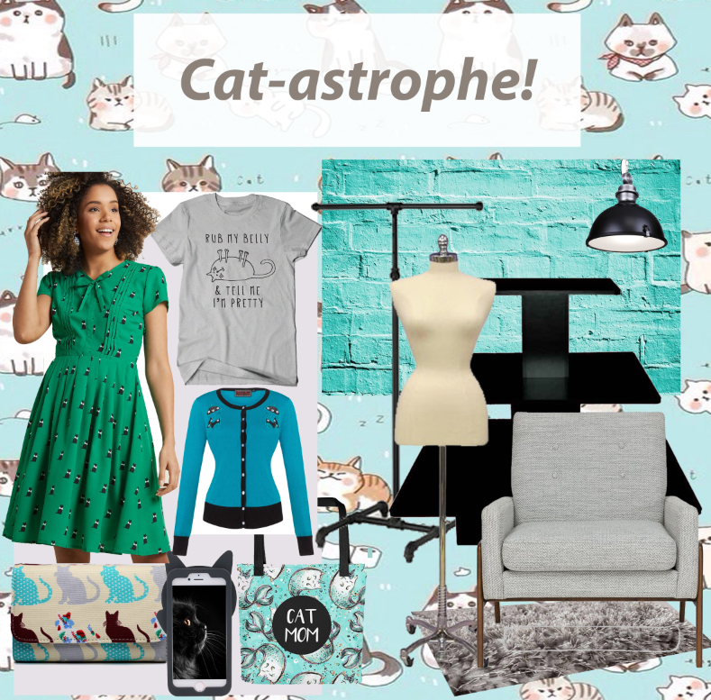
Floor Plan [Store Layout] Photoshop Illustration Requirements

Instructions: Based on your research and store observations, design an effective (successful at leading the customer throughout the entire store, includes strategic placement of focal points and allows for clear sightlines, and has enough space allocated in between fixtures for customers to move around comfortably). The design must be appropriate to store type, brand image, and target market. The design must reflect/conform to one of the basic store layouts discussed in lecture (grid, free-flow, racetrack, soft aisle, minimal, and combination). The store layout you design must improve on (be more effective than) the store layout that you observed and recorded when visiting the retailer for Store Design Inquiry Learning Project: Part 3. This means it cannot be the same layout that you sketched by hand.

Requirements:
- The store layout must include:
  - Common architectural symbols to indicate placement of fixtures and interior displays
    - The use of those provided on Canvas is strongly encouraged. However, if the student wishes to create their own symbols, they must be in line with the descriptions on pages 335-340 of the Pegler and Kong (2018) textbook.
  - Floor materials (rugs, carpet, wood, tile, etc.) appropriate to the store’s brand image
    - Inappropriate floor materials will reduce the layout’s effectiveness and will result in point deductions
  - Fixtures and interior displays must be appropriate to store type and brand image. In other words, they must make sense for that retailer.
    - For example, a clothing store carrying mostly basic items like t-shirts and cardigans will have more capacity fixtures like bins, cubes, and wall fixtures, than feature fixtures that hold fewer pieces of merchandise.
    - Inappropriate fixture type reduces the store layout’s effectiveness and will result in point deductions.
  - Fixtures must be placed on the store layout according to guidelines discussed in the lecture titled “Customer-Oriented Visual Merchandising, Fixtures & Dressing Fixtures, & Furniture as Fixtures and Props”
    - For example, because a round rack is a capacity fixture, it must be placed at the back of the store or department and not at the store entrance or along aisles.
    - Improper placement of fixtures reduces the layout’s effectiveness and will result in point deductions

Refer to the example of a Store Layout below, as well as Canvas> 4. Photoshop Lectures> Photoshop Lecture 2: Floor Plan_Store Layout> Floor Plan – Store Layout - Photoshop Lecture.docx for step-by-step instructions to create a store layout.

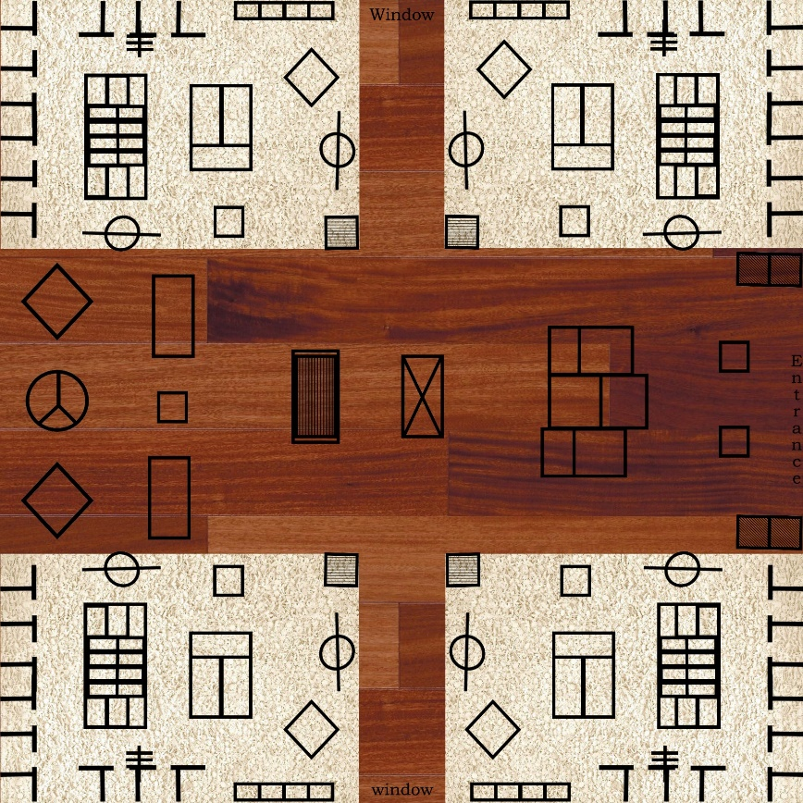
Planogram Photoshop Illustration Requirements
Instructions:
Based on your research and store observations, design a planogram for a back wall fixture (system). To ensure effectiveness of your apparel display, refer to the slide titled “Fashion Apparel & Accessory Displays” in the lecture titled “Customer-Oriented Visual Merchandising, Fixtures & Dressing Fixtures, & Furniture as Fixtures and Props”. Refer also to the lecture titled “Visual Merchandise and Store Planning” for information about planograms. The planogram of your back wall display must improve on (be more effective than) the back wall displays that you observed when visiting the retailer for Store Design Inquiry Learning Project: Part 3. The design must also be appropriate to store type, brand image, and target market.

Requirements:
- Images of the store’s products: The planogram must include images of branded products the store carries. For example, if you are studying H&M, the planogram must include images of H&M merchandise.
  - The images may come directly from the store’s website or from photographs you take when visiting the store. It is possible to process your own images of clothing pieces in Photoshop, but it may be challenging to obtain a clear, high-quality photo that shows the product at its best. The merchandise can be older (preferably from within the last 6 months to a year) if finding a high-quality image of current merchandise online or elsewhere is challenging
- Wall fixture: The planogram must accurately and realistically portray a type of wall fixture typically used by apparel retailers: Garment Rods & Crossbars, Slatwall, and gridwall. The wall fixture selected may be the type that your store currently uses or a type of wall fixture that you feel the retailer should use based on your observations and research.
- See explanation below for why we are doing a planogram of a wall fixture system:
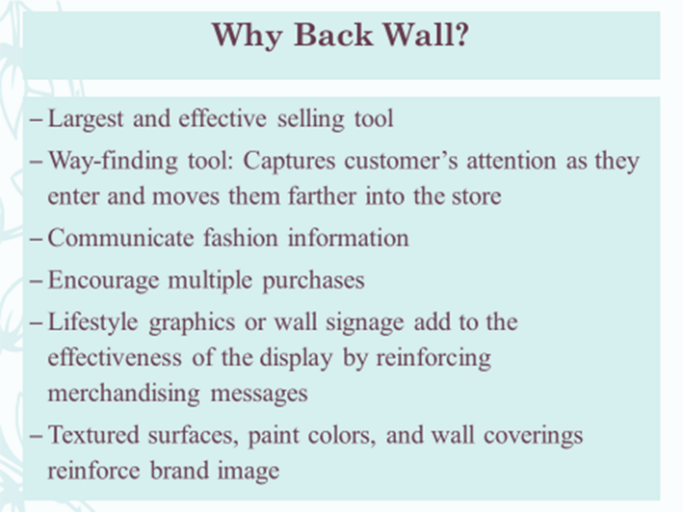

  - Notes:
    - While a planogram of a back wall is preferred, select a wall or area of the store that contains a wall fixture that you feel should be improved.
    - If your store does not use wall fixtures, see instructor to gain permission to create a planogram of a different type of fixture.
- Wall Material/Color: Include wall material or color if appropriate. For example, when using rod and crossbar wall fixtures, you may choose to include a brick wall behind the fixture. However, when using a slatwall (looks like wood siding on a house), the wall material is the same as the wall fixture (system). The wall material or color must be appropriate to store type, brand image, and target market.
- Demonstrates mastery of the elements of design and technical skill (Realistic proportions): The planogram must appear to be as realistic as possible. Be mindful that proportions of merchandise categories are realistic. For example, a pair of shoes must not be larger than a pair of slacks.
- Representative of recommendations/solutions proposed: The planogram you create must relate to the recommendations for improvement that you make regarding merchandise organization (what aspect is dominant? Coordination, size, brand, price, etc.), fixtures, and fixture presentation guidelines
- Customer-Oriented Visual Merchandising: The planogram must clearly show a dominant aspect (color, size, price, brand name/designer, coordination/style, or end use).
  - The dominant aspect must be appropriate to store type
- Fixture presentation guidelines: The planogram must demonstrate your understanding of fixture presentation guidelines as discussed in the lecture titled “Customer-Oriented Visual Merchandising, Fixtures & Dressing Fixtures, & Furniture as Fixtures and Props”
- Part 1: Develop Part 1 of the planogram using Photoshop. This is an image that displays merchandise as it appears on the wall.
  - Refer to the images below, as well as Canvas> 4. Photoshop Lectures> Photoshop Lecture 3: Planogram> Planogram Photoshop Lecture.docx for step-by-step instructions to create a planogram in Photoshop.

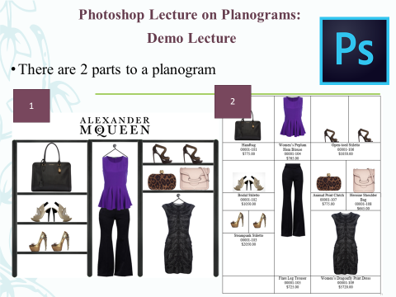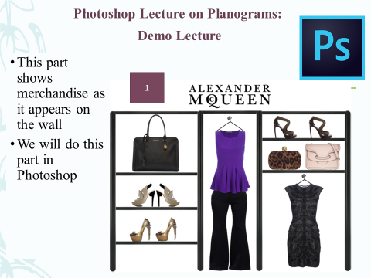

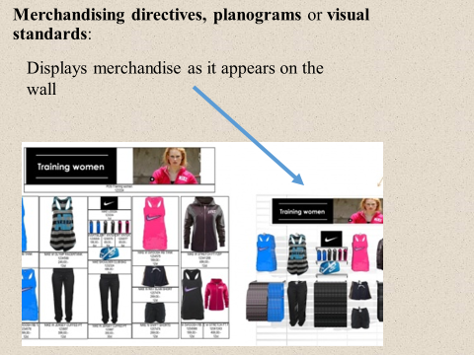

- Part 2: Develop Part 2 of the Planogram using Microsoft Word. This is a “Grid” that identifies where the exact merchandise will be placed by listing the product information beneath the image. The product name, style number, and price must be included underneath an image of each piece of merchandise. Refer to Canvas> 4. Photoshop Lectures> Photoshop Lecture 3: Planogram> Planogram Photoshop Lecture.docx for step-by-step instructions to create this part of the planogram using Microsoft Word.
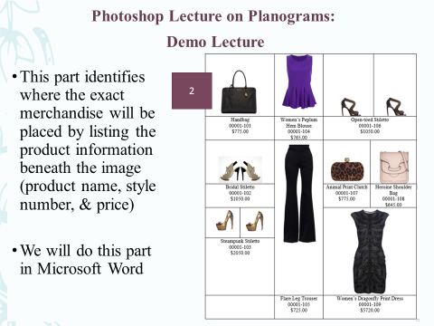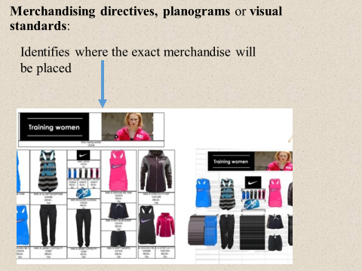

Store Design Inquiry Learning Project: Part 5:
PowerPoint Presentation & Oral Presentation

PowerPoint Presentation

What are we doing?: We are combining Store Design Inquiry Learning Project: Parts 1-4 into a single, unified PowerPoint Presentation.

Purpose: Why are we doing it? This assignment is designed to explore application of elements of design in developing an effective presentation using PowerPoint program. It is also developed to challenge the ability in analyzing research information and synthesizing it into concise slides content and present it in a logical fashion.

How will we be evaluated?: Refer to the rubric on page 3 of this document.

Instructions: Use the checkboxes below to check off each step as you read each point and complete the
assignment.
- Step 1: Use the PowerPoint template available on Canvas (template is size 21” Width and 11” Height and fits two square Photoshop pages sized 8 x 8, or 10 x 10 side by side on one slide) OR develop your content in PowerPoint program using Custom slide 21’ height and 11 inches width proportion
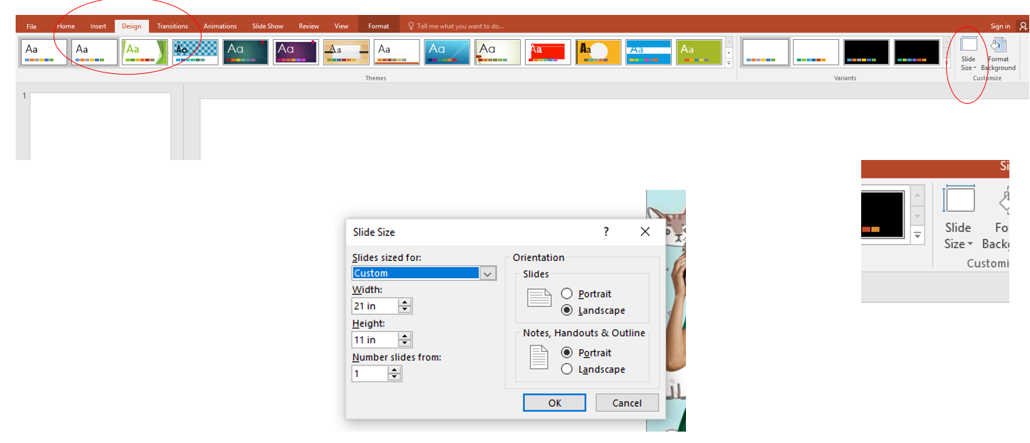

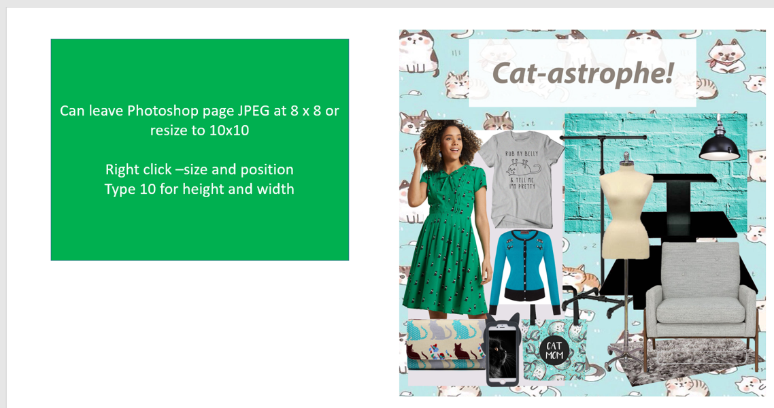
- Step 2: Develop a title page with your name, course, and date
- Step 3: Combine all slides from Store Design Inquiry Learning Project: Parts 1 - 4. This includes:
  - 7 slides for Part 1
  - At least 8 inquiries (at least 1 from each Inquiry Journal Entry completed in class) (inquiries may span multiple slides)
  - 3 slides from Part 3
  - All slides from Part 4
    - Slide with the Heading “Proposed Store Layout” containing Floor Plan/Store Layout Photoshop illustration
    - All slides that address all other inquiry questions
    - Slides that contain The Store Concept Storyboard and Planogram Photoshop illustrations
- Step 4: Move the “References” slide from Part 1 to the end of the PowerPoint Presentation.
    - Make sure any subsequent references used after submission of Part 1 are added to the Reference slide
- Step 5: Once slides are combined, identify an overall theme
  - Select color scheme that best illustrate your store’s aesthetic or signature look
  - Ensure that it is appropriate to your store’s brand image and target market
- Step 6: If necessary, edit all slides according to the overall theme and color scheme
- Step 7: Ensure that your PowerPoint slides should also demonstrate mastery of the elements of design (color, texture, line, composition, etc.) discussed in lecture
  - For example, are all elements on a single slide harmonious (matching colors, font sizes and styles, etc.)? Is there balance on the slide? Draw an imaginary line down the middle of the slide and imagine weighing it on an invisible scale. Does it “tip” over to one side?
- Step 8: Refer to Lecture: PPT Best Practices and ensure that all slides follow the guidelines discussed
  - Be selective with images/graphics in your presentation and consider slide visual impact (proportion and white space) when determine the scale and position of the images on your slides
  - Be selective with use of bullet/numbering and font color, style and size in consideration of overall layout design
  - Be sure to use legible font style: Sans Serif Fonts (Calibri, Arial, etc.); font size: 32-40 pt. for heading and 20-22 pt. for main text; use 1.1-1.2 pt. line spacing for main text, and consistent margin on your slides (BE CONSISTENT)
  - Be sure to select quality images as needed for your slides and properly position/arrange them considering slides proportion
  - All images used must be high in resolution. Be sure to not stretch image out of proportion (pull only at the corners of the images, not the center).
- Step 9: Use the following rubric as a checklist to ensure that you have completed the assignment
correctly:

Store Design Inquiry Learning Project: Part 5: PowerPoint Presentation Rubric
Adherence to assignment instructions: includes all slides and content listed above | /5 points
Professionalism of project: Presentation is free of grammar errors, Content is presented neatly - does not run off page or is “cut off.” | /6 points
Quality of PowerPoint:  Presentation:  PPT are formatted according to PPT:  Best Practices Lecture, demonstrates  mastery of the elements of design, is  properly sized to accommodate 8X8 or10 x 10  Photoshop images) | /5 points
Defined/Sound Methodology  Inquiry project/paper has defined focus, methodology or framework—active  research & sound reasoning | /16 points
Information Literacy  Project/paper indicates documentation of information—citations, evaluation and  inclusion of Sources—information literacy | /16 points
Critical Thinking  Considers differing perspectives, assesses data or evidence, reaches appropriate  conclusions—critical thinking. | /16 points
Analysis & Deliberation  Project/paper works as an academic paper in scope, focus, analysis, deliberation  and execution. | /16 points
Total Points Possible | /80 points

- Step 10: Canvas Submission: Go to Canvas and locate the assignment group titled “Store Design Inquiry Learning Project”
  - Within that group, click on the assignment titled “Part 5: PowerPoint Presentation & Oral Presentation”
  - Upload single PowerPoint file containing all slides by Thursday, December 6, 2018, at 12:30 PM

Oral Presentation

What are we doing? Students will orally present their creative and scholarly work they completed throughout the semester with their fellow students.

Purpose: Why are we doing it? This assignment is designed to allow students to share their creative and scholarly work, potentially providing inspiration and motivation for their fellow students on future projects, while also developing oral presentation skills.
How will we be evaluated?: Refer to the rubric below.

Instructions:
- Step 1: Sign up for a presentation number/order at the following link:
- https://docs.google.com/document/d/1f7UZ3ceQ2C252c4EWURo6Dq3sCieApFi2F5AAh3_Xbo/edit?usp=sharing
- Note that each student will be given only 4 minutes to briefly present their Store Design Inquiry Learning Project Presentation.
- Step 2: Practice your presentation at home and time yourself! Remember you only have 4 minutes.
- Step 3: Ensure that “Part 5: PowerPoint Presentation & Oral Presentation” was properly submitted to Canvas
  - The instructor will have your PowerPoint presentation downloaded on Canvas. If your submission did not go through on Canvas, it will delay all presentations. If your PPT presentation is not on Canvas and downloaded by the instructor, by 12:30 PM on the day of the presentation, you will only be able to present after all students have presented IF time permits. In other words, you may not be given an opportunity to present resulting in a loss of total points allotted for your oral presentation.
- Step 4: Show up and present your work in the order you selected.
  - Oral Presentation Tips:
    - Decide what you are going to talk about.
      - Do not plan on reading word-for-word from the screen
      - Summarize the information on some slides – you will not have time to discuss every slide in-depth
      - Explain select bulleted phrases in depth
      - Point out your favorite slides and spend more time talking about it
    - Pace yourself
      - Scroll through your slides and give the audience enough time to view the content on each slide. In other words, do not scroll or click through so quickly that the audience cannot take in the information presented.
    - If you use animations, use them sparingly as a tool for pacing so they are not too distracting
    - Speak audibly and loudly
      - Face the audience not the screen
      - Make eye contact
    - Walk around the room if you want
- Step 5: Stay within the 4-minute time limit. Going over time may result in a loss of points.
- Step 6: Arrive on time at the beginning of class and stay the whole time.
  - Students are expected to attend ALL oral presentations. Note my policy for missing presentations (this is included on the syllabus):
    - If a student is tardy or absent on the day Final Presentations (PPT & Oral) are scheduled, the student will lose 2 points for each presentation they missed, as these are considered mandatory in-class activities that cannot be made up regardless of whether or not tardiness or absence is excused
  - Students must give speakers their full attention. Note the following policy listed on the syllabus: Laptops must be stored in your bag, under your desk, or closed during student presentations and while the instructor is explaining and review assignment instructions.
- Step 8: Use the following rubric as a checklist to ensure that you have completed the assignment
correctly:

Store Design Inquiry Learning Project: Part 5: Oral Presentation Rubric
Preparedness | /10 points
Part 5: PowerPoint Presentation & Oral Presentation” was properly submitted to Canvas and downloaded by the instructor by 12:30 PM | /10 points
Student has prepared in advance what he/she will say (does not read word-for-word from the screen, summarizes the information on some slides, explains select bulleted phrases in depth, points out favorite slides and spends more time talking about them) | /10 points
Presents in the number/order allotted | /10 points
Pacing | /5 points
Moves through slides at a pace that allows the audience cannot take in the information presented | /5 points
Uses animations sparingly and appropriately | /5 points
Confidence | /5 points
Speaks audibly and loudly | /5 points
Faces audience and makes eye contact with the audience | /5 points
Attendance & Respectfulness | -2 points off total course grade for each  presentation missed  -2 points off total course grade per presentation if he/she does not give speaker his/her full attention  If a student misses his/her own presentation and does not have a documented excused absence, the student will receive a 0 for the oral presentation.
Attends all other students’ presentations: arrives to class on time and stays throughout the entire period

Student gives speakers their full attention (Laptops are stored in a bag, under a desk, or closed during student presentations)
Total Points Possible | /20 points

